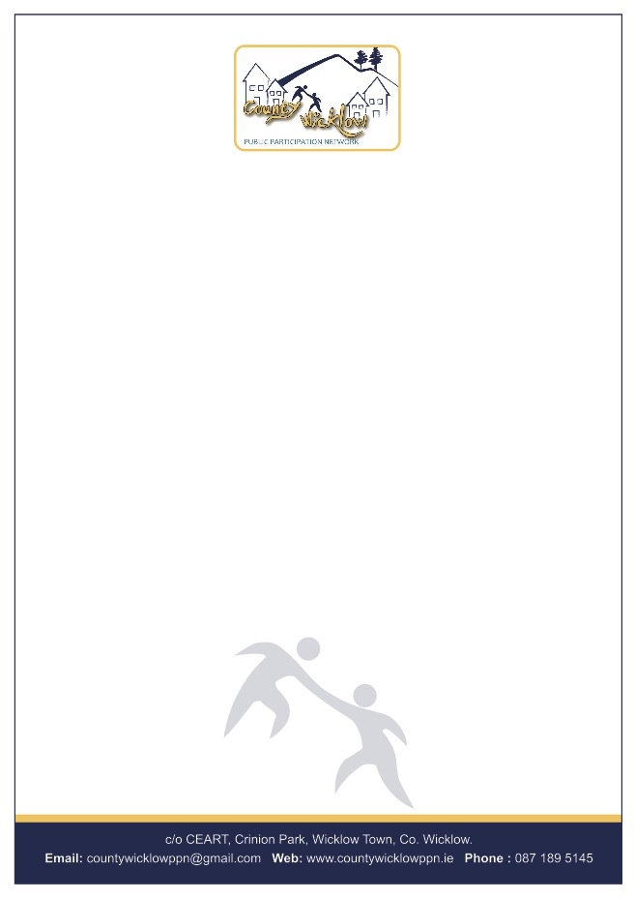

26th July 2018

Mr Aidan Moore

Lobbying Regulation Unit

Standards in Public Office Commission

18 Lower Leeson Street

Dublin 2

DO2 HE97

**Re: Draft Code of Conduct for Persons Carrying on Lobbying Activities**

Dear Aidan

Thank you for your Email dated 9th July 2018 in regard to the Draft Code of Conduct for Persons Carrying on Lobbying Activities which the Secretariat of Co Wicklow PPN discussed at their meeting on Tuesday 24th July 2018. Co Wicklow PPN welcomes the opportunity for clarity and transparency in relation to lobbying activities and appreciates the invitation to participate in the consultation.

Having studied the draft, the Secretariat thought that it covered all the necessary aspects of lobbying activities in a clear and concise manner with due regard to safeguarding against inappropriate impacts.

While the Secretariat had nothing to add to the content of the document they stressed the importance of circulating the final policy extensively, ensuring that people know about it, understand it and appreciate its importance. They would also highlight the importance of implementing it so that lobbying activities are conducted ethically at all times.

Co Wicklow PPN hopes that these suggestions are considered carefully and looks forward to receiving a copy of the final policy.

Yours sincerely,

Helen Howes, Resource Worker

On behalf of the Secretariat

Co Wicklow PPN